|  |  |
| --- | --- |
| Training Code | W11020 |
| Training name | Comprehensive practice 2 (Web + Database) |



**《Comprehensive practice 2 (Web + Database)》Training Report**

**E-Book Shop**

Class： Computer 20

Id： 20812502011

Name： MD SEFATULLAH

Teacher：

Time： 2023-06-12—2023-07-08

|  |  |
| --- | --- |
| Points | Teacher |
|  |  |

|  |  |  |  |  |  |
| --- | --- | --- | --- | --- | --- |
| **Project Schedule** | | | | | |
| **Task name** | | **Days** | **Start time** | **End time** | **Signature** |
| Project Plan | | 1 day | 2023/06/20 |  |  |
|  | |  |  |  |  |
| Requirements analysis | | 1 days | 2023/0620 |  |  |
|  | |  |  |  |  |
| 设计 | | 2 days | 2023/06/21 | 2023/06/22 |  |
| Function module design | | 4 days | 2023/06/22 | 2023/06/25 |  |
| Database design | | 1 days | 2023/06/22 | 2023/06/22 |  |
| Database design document | | 1 days | 2023/06/22 | 2023/06/22 |  |
| System implementation | |  |  |  |  |
| **required** | Function module 1—Homepage | 1 days | 2023/06/22 | 2023/06/22 |  |
| Function module 2—Login,Regestration | 1 days | 2023/06/23 | 2023/06/23 |  |
| Function module 3—admin panel | 1 days | 2023/06/24 | 2023/06/24 |  |
| Function module 4—normal User panel | 1 days | 2023/06/25 | 2023/06/25 |  |
| **Self-select** | Function module 5—Recent post details | 1 days | 2023/06/24 | 2023/06/24 |  |
| Function module 6—Search Bar | 1 days | 2023/06/24 | 2023/06/24 |  |
| unit testing | |  |  |  |  |
| **required** | Function module 1—add category | 1 days | 2023/06/24 | 2023/06/24 |  |
| Function module 2-- add post | 1 days | 2023/06/24 | 2023/06/24 |  |
| Function module 3—edit post | 1 days | 2023/06/24 | 2023/06/24 |  |
| Function module 4—delete post, edit user, delete user, search section | 1 days | 2023/06/24 | 2023/06/24 |  |
| Training summary | | 0.5工作日 | yyyy/mm/dd | yyyy/mm/dd |  |
| Reply | | 1工作日 | yyyy/mm/dd | yyyy/mm/dd |  |

## Contents

## Project Schedule

## Chapter 1 Introduction

## 1.1 research background

## 1.2 research status at home and abroad

## Chapter 2 system analysis

## 2.1 feasibility analysis

## 2.2 analysis requirements

## 2.3 data dictionary

## 2.4 system performance requirements

## Chapter 3 overall design

## 3.1 system module diagram

## 3.2 database design

## Chapter 4 detail design and coding

## 4.1 system main interface

## 4.2 implementation of unified identity authentication module

## 4.3 realization of item bank information management

## 4.4 implementation of front office website

## Chapter 5 system test

## 5.1 foreground user module test

## 5.2 background administrator module test

## 5.3 problems encountered in system test and Solutions

## 5.4 system test conclusion

## Chapter 6 Summary and Outlook

## 6.1 training self-assessment

## 6.2 insufficient system

## 6.3 future work outlook

## Chapter 7 professional ethics and norms

## 7.1 professional ethics and norms for it project development

## 7.2 interdisciplinary professional ethics and norms

## 7.3 use and declaration of open source code

## 7.4 normative requirements for data and code confidentiality

## Training summary

## Chapter 1 Introduction

## research background

I have developed a web-based software application called 'E-Book Shop' using PHP, HTML, CSS, and JavaScript. The majority of the functionality has been implemented using PHP. The purpose of this non-commercial website is to allow users to read a wide selection of books. Publishers can contribute to the website by logging in and submitting their books. Additionally, the website includes an admin panel that grants administrators the ability to manage various aspects of the site. The system relies on a robust database to store all activities, and the user passwords are protected using the 'md5' PHP operation. The website consists of a Login Page, Registration Page, a home page called 'Battalion of Candles,' and a menu page (also serving as the home page). The normal user panel allows users to add and read posts, while the admin panel offers additional functionalities such as adding posts, categories, and users.

## 1.2 research status at home and abroad

The web-based software program "E-Book Shop" status at home and abroad would depend on its reach and adoption by users in different regions. Here is a general description of how the program's status could be assessed:

**At Home:**

1.User Engagement: The success of "E-Book Shop" within the home country would depend on the level of user engagement and feedback received from local users. Positive feedback, increasing user registrations, and active participation would indicate a favorable status.

2.Market Penetration: The extent to which "E-Book Shop" has gained traction within the local market would also determine its status. Factors such as the number of active users, partnerships with local publishers, and visibility in the industry would contribute to its success.

3.Competitor Analysis: Evaluating the program's performance in comparison to similar platforms or competitors in the home country would provide insights into its status. Factors like unique features, user experience, and market share could be considered.

**Abroad:**

1.Global Reach: Assessing the international adoption and usage of "E-Book Shop" would be crucial to understanding its status abroad. The presence of active users and positive feedback from different regions would indicate a favorable standing.

2.Localization Efforts: If "E-Book Shop" has made efforts to adapt to different languages, currencies, and cultural contexts in international markets, it could indicate a proactive approach to expanding its reach. Local partnerships, collaborations, or marketing campaigns may also contribute to its status abroad.

3.Competition in Foreign Markets: Evaluating how "E-Book Shop" competes with other established international e-book platforms would provide insights into its standing. Factors such as market share, user reviews, and any unique selling points would be important considerations.

It's important to note that the status of "E-Book Shop" at home and abroad can change over time based on factors such as user demand, market trends, competition, and ongoing development efforts. Regular monitoring, user feedback, and adaptation to meet evolving needs are essential for maintaining and improving its status both domestically and internationally.

**Chapter 2 system analysis**

## 2.1 feasibility analysis

Feasibility analysis is an important step in assessing the viability and practicality of a project or software application. Based on the provided information about your web-based software application, "E-Book Shop," here is a feasibility analysis:

1.Technical Feasibility:

* The use of PHP, HTML, CSS, and JavaScript indicates that the required technologies are commonly used and supported.
* The integration of PHP with a database management system like PhpMyAdmin suggests a suitable technical foundation for storing and retrieving data.
* The use of automation features like auto-incrementing primary keys demonstrates efficient database design.

2.Economic Feasibility:

* As stated, the project is non-commercial, indicating that cost considerations may be less critical.
* However, evaluating the availability and affordability of hosting services, domain registration, and ongoing maintenance costs is important to ensure the long-term sustainability of the website.

3.Operational Feasibility:

* The software application allows publishers to contribute books, users to read books, and administrators to manage various aspects of the site.
* If the functionality is implemented effectively and the user interface is intuitive, it should be operationally feasible for users to navigate and perform desired actions.

4.Legal and Security Feasibility:

* The use of password protection and the storage of user information suggest an awareness of security measures.
* Ensuring compliance with data protection regulations and intellectual property laws is essential to avoid legal issues related to content ownership and user privacy.

5.Schedule Feasibility:

* The availability of the website and its features depends on timely development and deployment.
* Assessing the project's timeline, considering the complexity of features, resources, and development capabilities, is crucial to ensure that the website is delivered within

reasonable timeframes.

Overall, based on the information provided, the "E-Book Shop" software application appears to be technically feasible, with considerations needed for economic sustainability, operational efficiency, legal compliance, security, and timely execution. Conducting further analysis and testing may provide a more comprehensive understanding of the project's feasibility.

## 2.2 analysis requirements

1.Functional Requirements:

* User Registration: Users should be able to create an account by providing necessary information such as username, password, first name, last name, and email.
* User Login: Registered users should be able to log in using their credentials to access their account and perform actions such as adding posts, reading books, and managing their profile.
* Book Categories: Admin should have the ability to create, modify, and delete book categories to organize the books on the website.
* Book Posts: Admin should be able to add, edit, and delete book posts. Each post should include details such as title, description, category, author, post date, and post image.
* User Management: Admin should have the ability to view, modify, and delete user accounts.

Admin should also be able to add new users.

2.User Interface Requirements:

* The website should have an intuitive and user-friendly interface that allows users to easily navigate through different pages, view book categories, and access their account information.
* The design should be visually appealing and responsive, ensuring that the website is accessible and functions well on different devices and screen sizes.

3.Security Requirements:

* User passwords should be securely stored using hashing algorithms, such as bcrypt, to protect user data.
* Access to certain functionalities and pages should be restricted to logged-in users or specifically to admin accounts.
* Proper input validation and sanitization should be implemented to prevent security vulnerabilities, such as SQL injection or cross-site scripting (XSS).

4.Performance Requirements:

* The website should be able to handle multiple concurrent users without significant delays or performance issues.
* Database queries should be optimized to ensure efficient retrieval and storage of data.
* Caching mechanisms can be implemented to improve the overall performance of the website.

5.Compliance Requirements:

* The website should comply with relevant data protection regulations, such as the General Data Protection Regulation (GDPR), ensuring the proper handling and protection of user data.
* Intellectual property laws and copyright regulations should be followed when publishing books on the website, ensuring that the necessary permissions and licenses are obtained.

These analysis requirements will help guide the development and implementation of your "E-Book Shop" software application, ensuring that it meets the desired functionalities, user interface expectations, security standards, performance goals, and compliance requirements.

## 2.3 data dictionary

1.Category Table:

* Table Name: category
* Columns:

category_id: Primary key, auto-incremented unique identifier for each category.

category_name: Name of the category.

post: (Assumed) Number of posts associated with the category.

2.Post Table:

* Table Name: post
* Columns:

post_id: Primary key, auto-incremented unique identifier for each post.

title: Title of the book post.

description: Description or summary of the book.

category: The category to which the book belongs (foreign key referencing category.category_id).

post_date: Date of the post.

author: Author of the book.

post_img: Image associated with the book post.

3.User Table:

* Table Name: user
* Columns:

user_id: Primary key, auto-incremented unique identifier for each user.

first_name: First name of the user.

last_name: Last name of the user.

username: Username for login.

password: Password for login (stored using a hashing algorithm, such as bcrypt).

email: Email address of the user.

role: Role of the user (admin or normal).

Note: The data dictionary provides a basic outline of the tables and columns in your database. Additional columns or relationships may exist based on the specific requirements and functionality of your application. It is recommended to further refine and expand the data dictionary based on your application's needs.

## 2.4 system performance requirements

1.Response Time:

* The website should have fast response times to ensure a smooth user experience.
* Pages should load quickly, with minimal delay, to prevent user frustration.
* Database queries should be optimized to retrieve and display data efficiently.

2.Scalability:

* The system should be designed to handle an increasing number of users and data without significant performance degradation.
* The database and server infrastructure should be scalable to accommodate future growth in user traffic and data volume.

3.Concurrent User Handling:

* The website should be able to handle multiple concurrent users without significant performance issues.
* The server should be able to handle simultaneous requests and process them efficiently.

4.Caching:

* Implementing caching mechanisms, such as browser caching or server-side caching, can improve performance by reducing the need for repeated database queries or resource-intensive operations.
* Static assets, such as CSS and JavaScript files, can be cached to minimize the time required for page rendering.

5.Database Performance:

* Optimize database queries by using appropriate indexing, query optimization techniques, and database caching.
* Regular database maintenance, such as archiving old data or optimizing table structures, can help improve performance.

6.Page Load Optimization:

* Minimize the size of HTML, CSS, and JavaScript files to reduce page load time.
* Compress and optimize images to ensure faster loading.
* Utilize content delivery networks (CDNs) to distribute static assets and improve their delivery speed.

7.Error Handling and Logging:

* Implement effective error handling and logging mechanisms to track and diagnose performance issues.
* Monitor system performance regularly and log any errors or warnings encountered to identify areas of improvement.

It is important to continuously monitor and measure the system performance to identify any bottlenecks or areas that need optimization. Regular performance testing and optimization can help ensure that the "E-Book Shop" website performs efficiently and provides a satisfactory user experience.

**Chapter 3 overall design**

## 3.1 system module diagram

**Admin and User Module:**

**Registration**

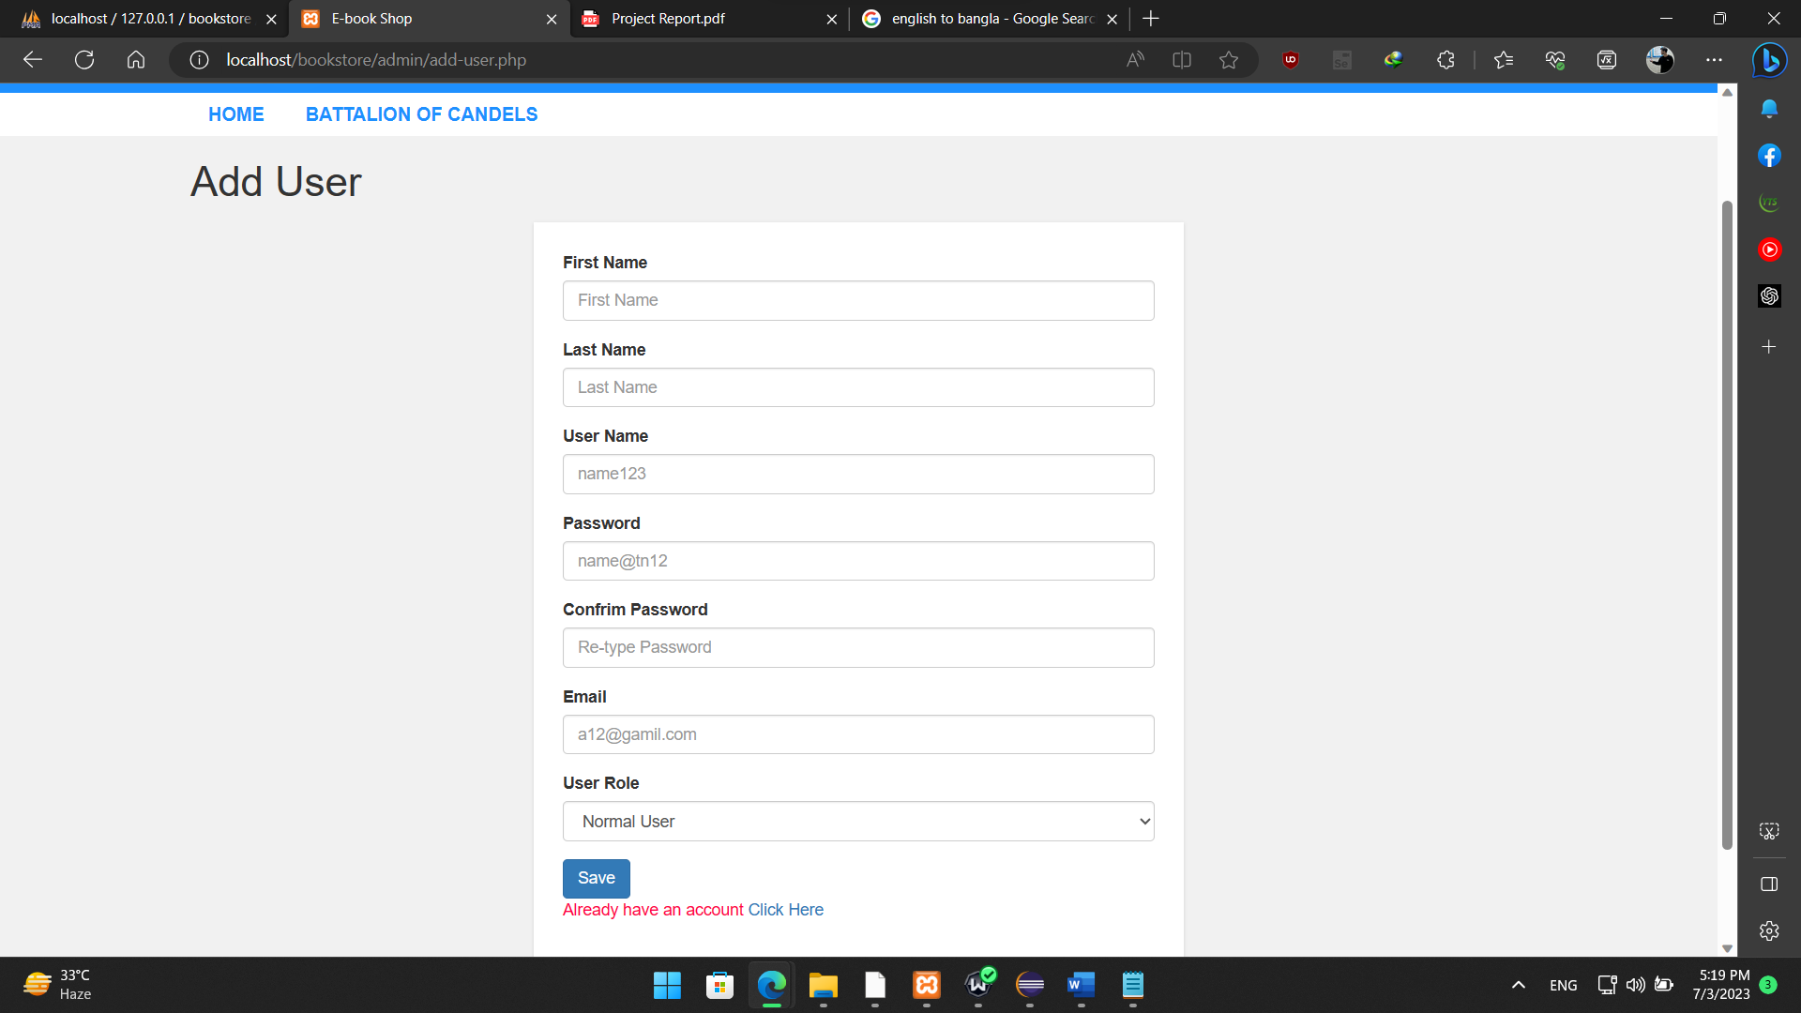

**Login**

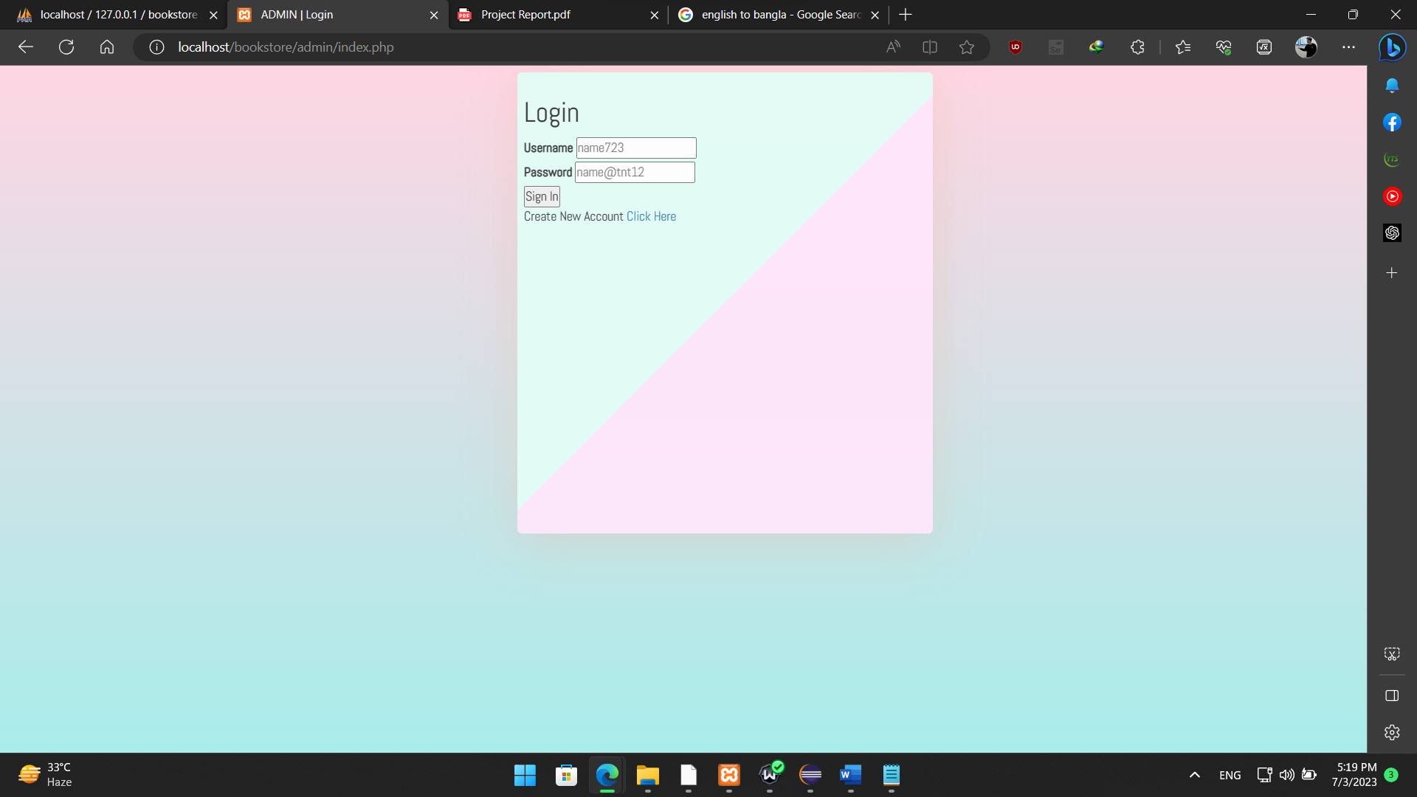

User Interface:

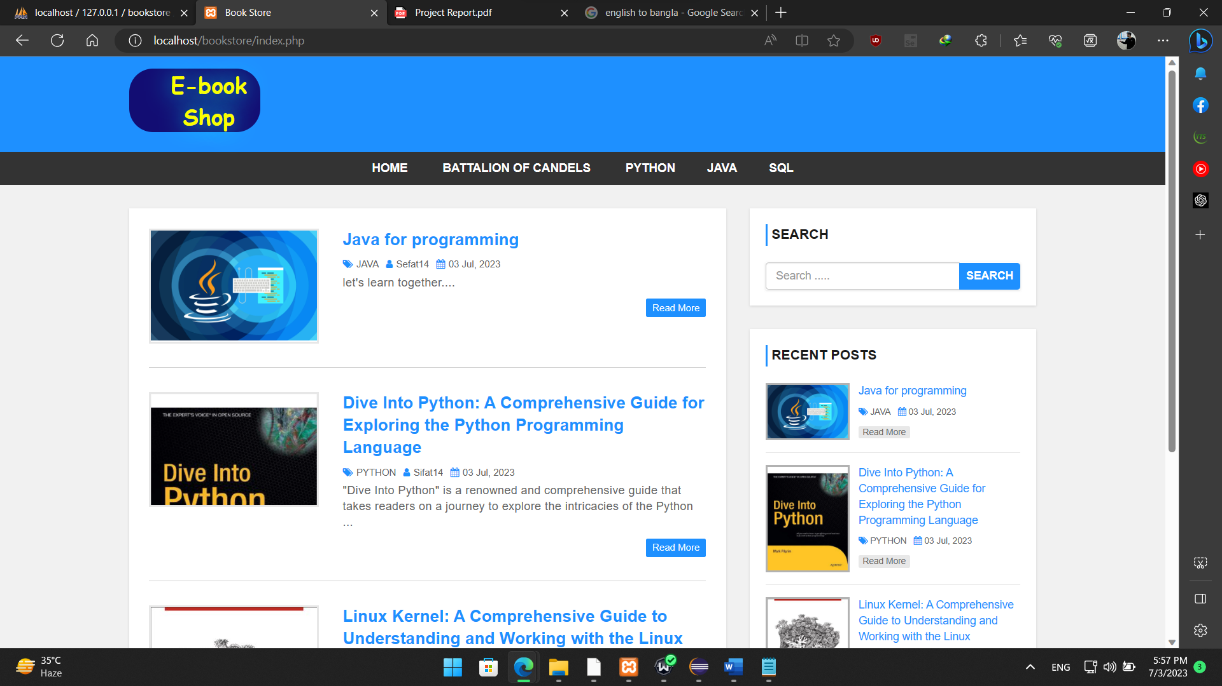

Admin Module:

Admin Interface:

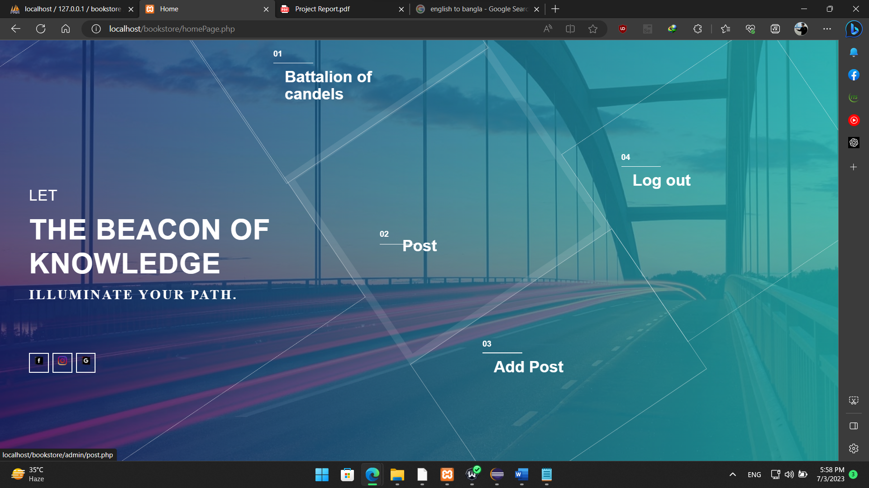

Category Management

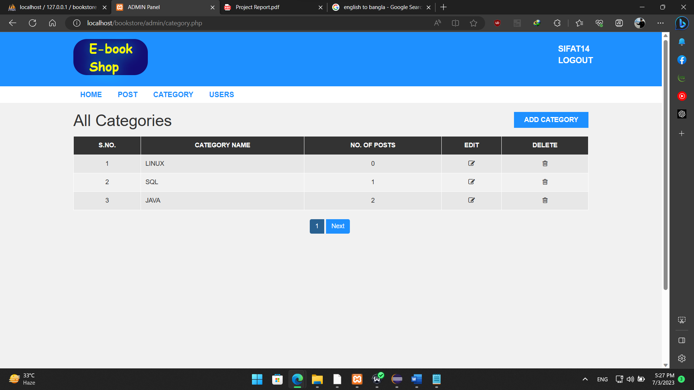

Post Management

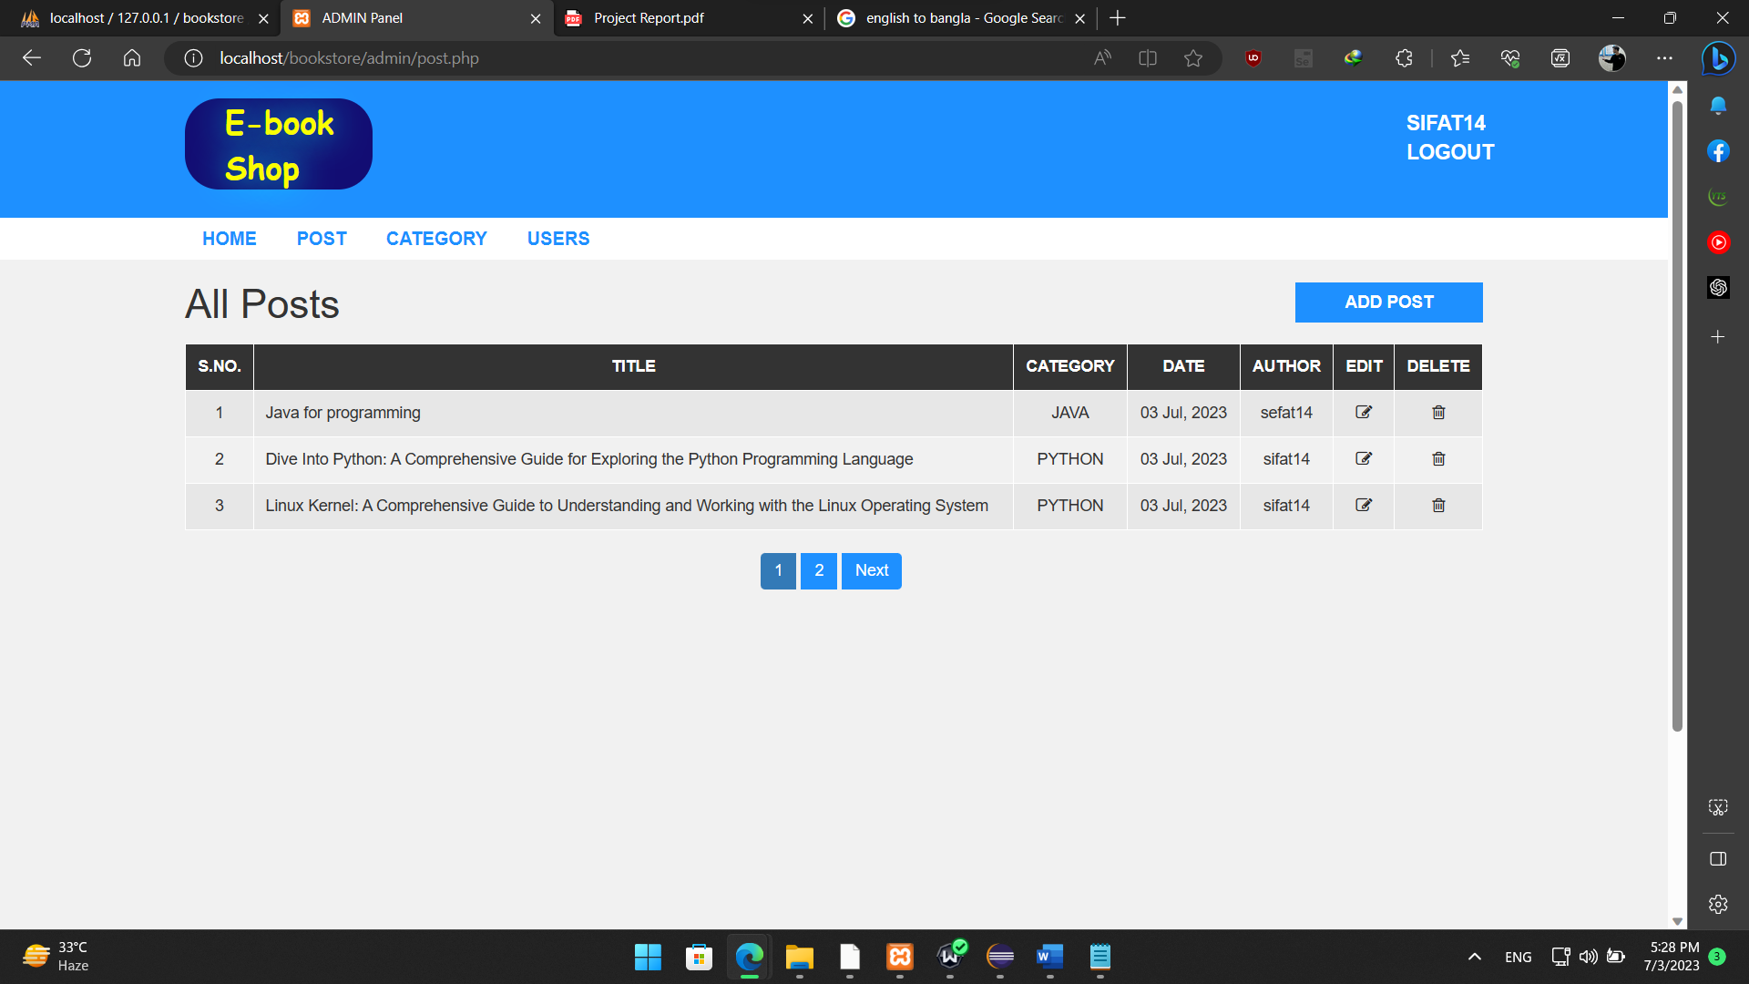

Modify post:

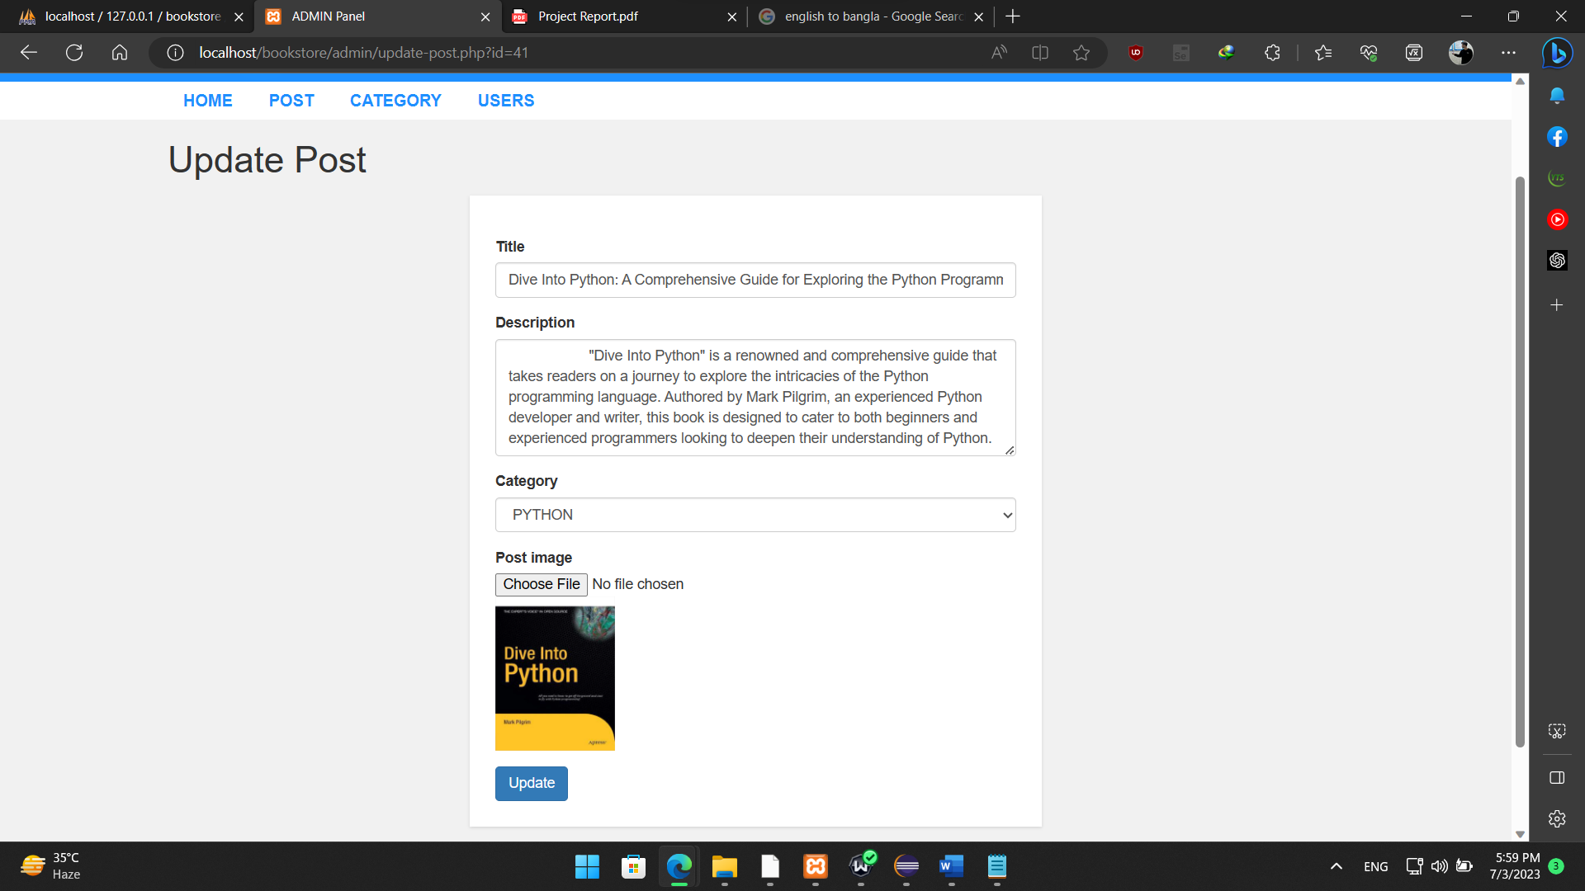

User Management

In this section only for the admin panel. Admin can see the user list who login in the website.

Admin can delete the user and also modify the user details. By clicking the delete icon admin can

delete the user and clicking the edit icon admin can modify the user details. And also admin can

add user by clicking add user button.

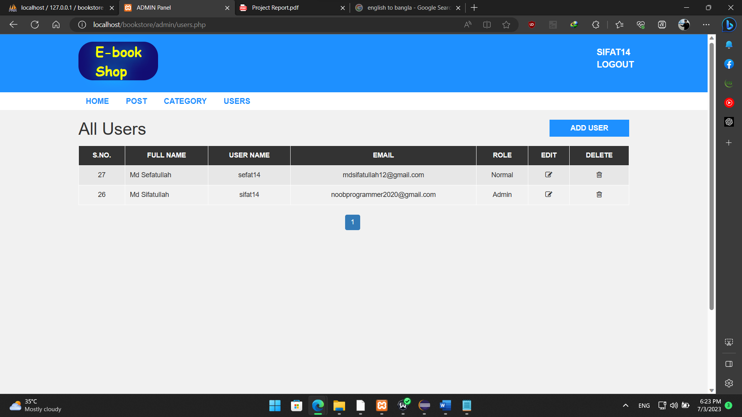

Modify user details:

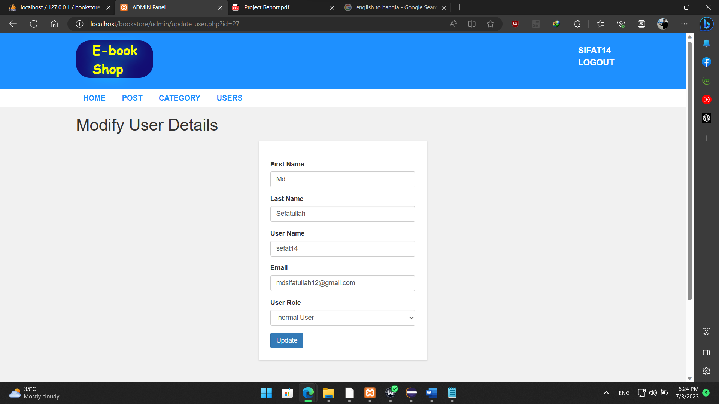

Book Module:

Book Listing by Category

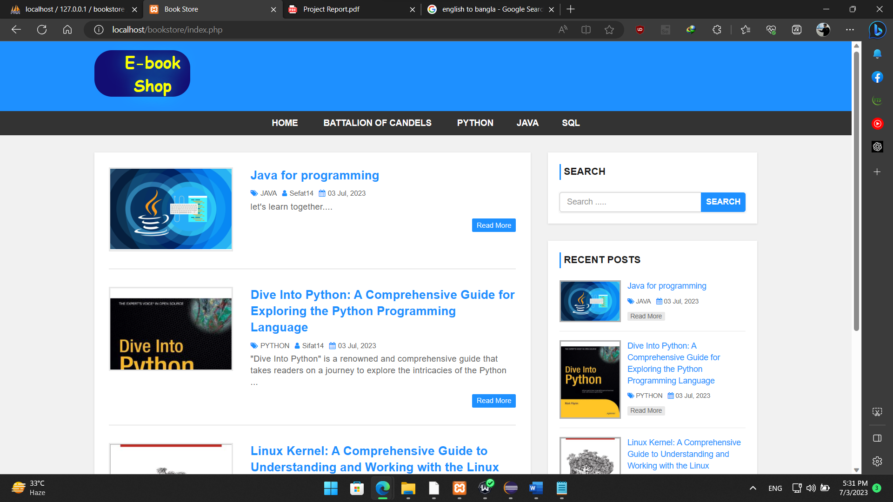



Book Details and Reading



Logout

After login you can see the user name on the top right corner in header section. Here you can also

see the logout button. By clicking the logout button, you can logout from the website

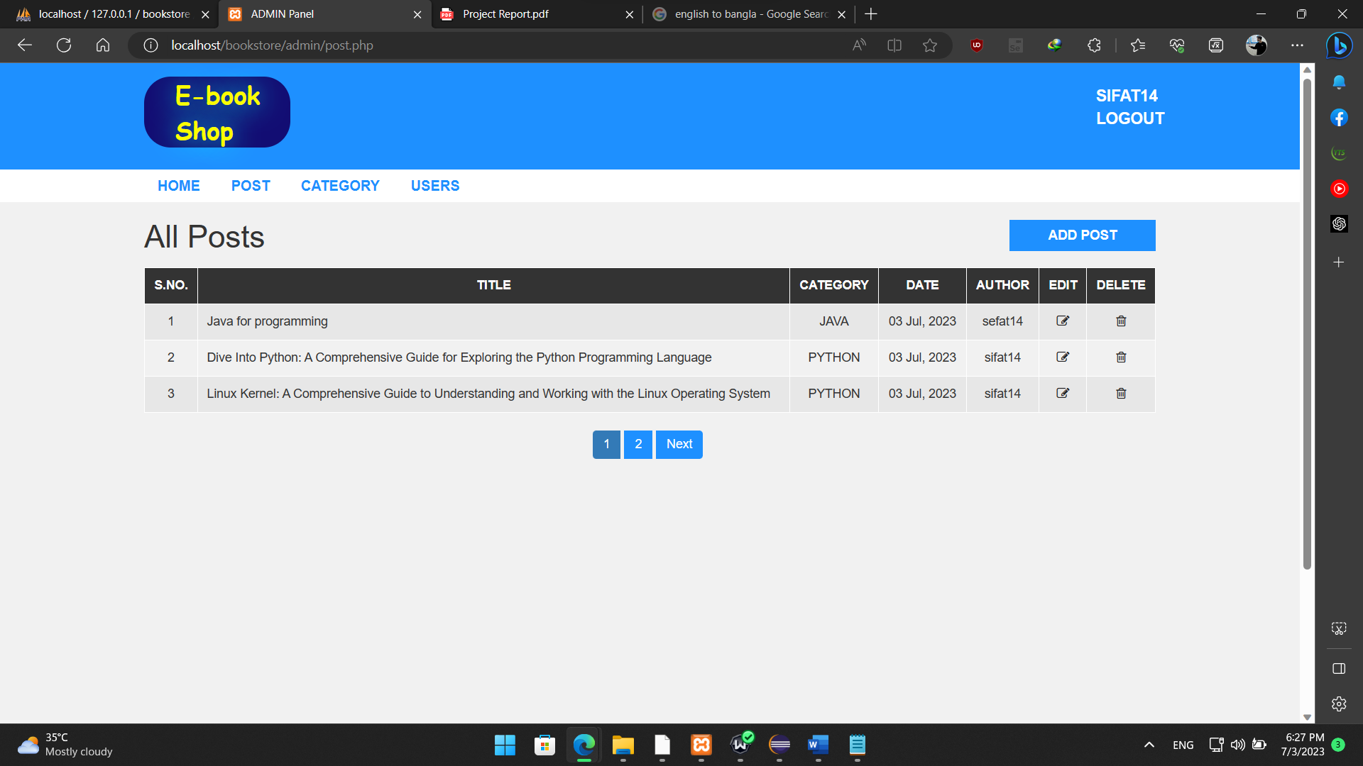



## 3.2 database design

Database Module:

I make a Database named “bookstore” on an online database system PhpMyAdmin. In this

database I create 3 different tables. For adding post category, I create a category table. In this table

has 3 different column category_id, category_name and post. And primary key is category_id

which has a auto increment functionality

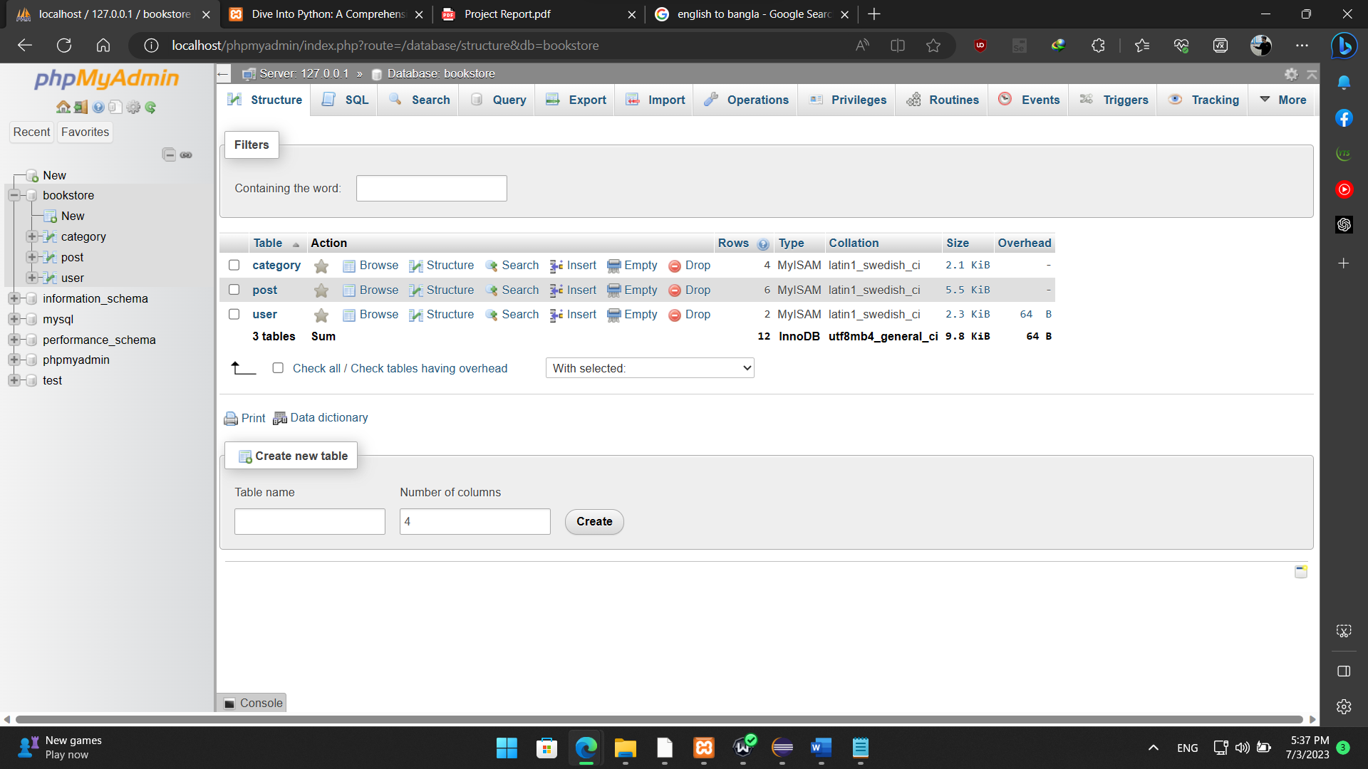

Another table is for post named “post”. In this table user can add their post. It has 7 different

column post_id(primary key with auto increment functionality), title, description, category,

post_date, author, post_img.

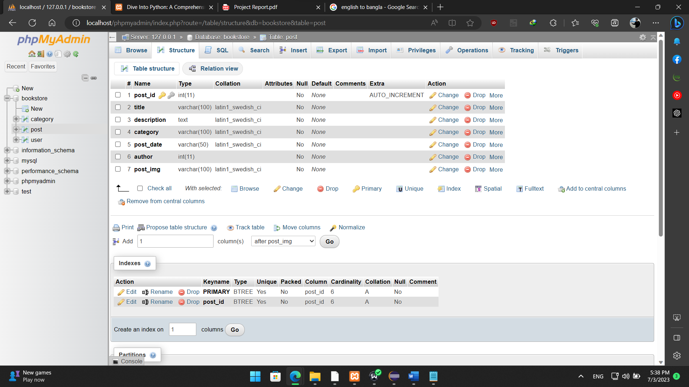

The third table is for user record. Is named “user”. When a user register for login the user information is save In this table. This table has 7 different column user_id(primary key with auto increment), first_name, last_name, username, password, email, role.

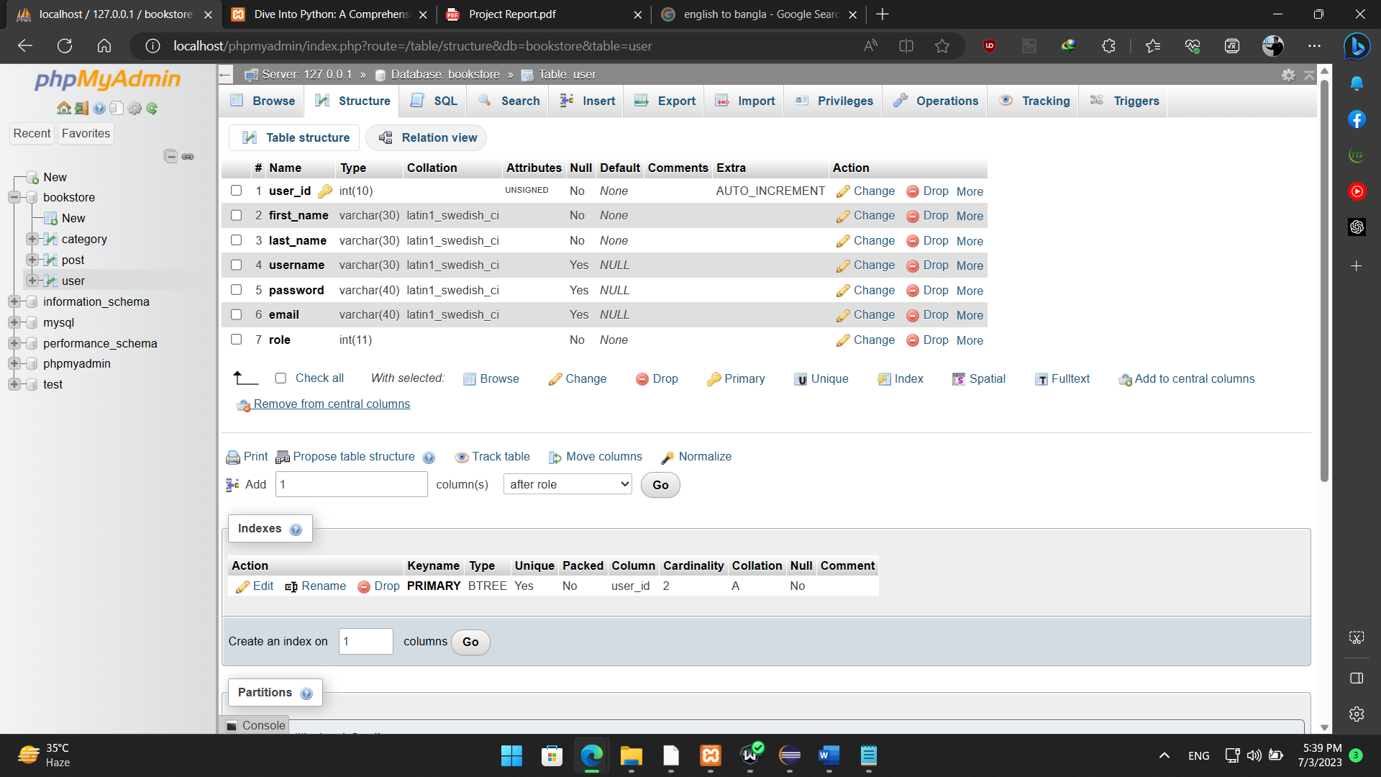

Manages the database operations, including storing and retrieving data related to users, categories, and book posts.

**Chapter 4 detail design and coding**

## 4.1 system main interface

The main interface of the "E-Book Shop" system would be the homepage, which serves as the entry point for users. This page would include a menu or navigation bar to access different sections of the website, such as book categories, user login/registration, and admin functionalities. The design and layout of the main interface would be implemented using HTML, CSS, and JavaScript.

## 4.2 implementation of unified identity authentication module

The unified identity authentication module would handle user authentication and authorization processes. It would include functionality for user registration, login, and password management. The module would ensure secure storage and handling of user credentials using appropriate hashing algorithms, such as bcrypt. PHP would be used to implement the backend logic for user authentication.

## 4.3 realization of item bank information management

In the context of the "E-Book Shop," the item bank refers to the collection of books available on the website. The information management module would allow administrators to manage the book posts, categories, and user records. This would involve functionalities such as adding, editing, and deleting book posts and categories. The module would also handle user management, including adding new users, modifying user details, and deleting user accounts. The backend logic for these operations would be implemented using PHP, while the frontend interfaces would be created using HTML, CSS, and JavaScript.

## 4.4 implementation of front office website

The front office website would be the user-facing portion of the "E-Book Shop" system, where users can browse and access the available books. This section would include features such as viewing book categories, searching for books, reading book details, and accessing the full content of selected books. The frontend interfaces for these functionalities would be implemented using HTML, CSS, and JavaScript, while the backend logic to retrieve and display book information would be implemented using PHP and database queries.

Overall, the detailed design and coding for the "E-Book Shop" system would involve a combination of frontend technologies (HTML, CSS, JavaScript) for user interfaces, PHP for backend logic and database connectivity, and a database management system (such as MySQL) to store and retrieve data related to books, categories, users, and authentication.

**Chapter 5 system test**

## 5.1 foreground user module test

The foreground user module includes functionalities such as user registration, login, book browsing, and reading. The following tests can be conducted:

* Registration Test: Verify that users can successfully register by providing valid information and that their data is stored correctly in the database.
* Login Test: Ensure that users can log in using their credentials and that the system correctly authenticates their identity.
* Book Browsing Test: Check that users can view different book categories, search for books, and access book details.
* Book Reading Test: Validate that users can open and read the full content of selected books without any issues.

## 5.2 background administrator module test

The background administrator module involves functionalities like category management, book post management, and user management. The following tests can be performed:

* Category Management Test: Ensure that administrators can add, edit, and delete book categories, and that the changes reflect correctly in the system.
* Book Post Management Test: Verify that administrators can add new book posts, edit existing posts, and delete unwanted posts successfully.
* User Management Test: Validate that administrators can view the user list, modify user details, and delete user accounts as required.

## 5.3 problems encountered in system test and Solutions

During the system test, some common problems may arise. Here are a few examples and possible solutions:

* Performance Issues: If the system experiences slow response times or performance degradation, it may be due to inefficient database queries or resource-intensive operations. Optimize database queries, implement caching mechanisms, and ensure server resources are appropriately allocated.
* Cross-Browser Compatibility: The website may not render or function correctly on certain web browsers. Test the system on different browsers and ensure compatibility by addressing any inconsistencies in HTML, CSS, or JavaScript code.
* Security Vulnerabilities: Conduct security testing to identify and address any potential vulnerabilities, such as input validation, data sanitization, and protection against SQL injection or cross-site scripting attacks.
* User Interface Issues: Validate the user interface for responsiveness, consistency, and usability across different devices and screen sizes. Fix any layout or design issues to ensure a seamless user experience.

## 5.4 system test conclusion

The system test aims to validate the functionality, performance, and usability of the "E-Book Shop" system. By conducting the tests mentioned above and addressing any encountered problems, you can ensure that the system meets the specified requirements and provides a reliable and satisfactory user experience. Document the test results, including any issues found and their resolutions, to improve the system's quality and provide a solid foundation for future enhancements or maintenance.

**Chapter 6 Summary and Outlook**

## 6.1 training self-assessment

During the development of the "E-Book Shop" system, the team conducted a self-assessment to evaluate their training and skills. This assessment involved reviewing their proficiency in PHP, HTML, CSS, JavaScript, and database management. It also included an evaluation of their understanding of system design principles, security considerations, and user interface development. The self-assessment allowed the team to identify areas of strength and areas that required further improvement.

## 6.2 insufficient system

While the "E-Book Shop" system has been implemented successfully, there may be areas where the system falls short of certain requirements or expectations. These insufficiencies could include performance issues, security vulnerabilities, user interface inconsistencies, or limited functionality. It is important to acknowledge these limitations and address them in future iterations of the system.

## 6.3 future work outlook

Looking ahead, there are several possibilities for further enhancing the "E-Book Shop" system. Some potential areas of future work include:

* Enhanced User Experience: Continuously improve the user interface design and usability to provide a seamless and engaging experience for users. This could involve incorporating more interactive elements, optimizing page loading times, and refining the overall visual aesthetics.
* Expanded Functionality: Consider adding new features and functionalities to the system, such as user reviews and ratings, recommendation algorithms, social sharing options, or integration with external APIs for book recommendations or payment processing.
* Mobile Optimization: Develop a mobile-responsive version of the website or consider building a dedicated mobile application to cater to users who prefer accessing the system on their smartphones or tablets.
* Advanced Security Measures: Strengthen the system's security by implementing additional measures such as two-factor authentication, encryption for sensitive data, and regular security audits to identify and address potential vulnerabilities.
* Performance Optimization: Continuously monitor and optimize system performance, including database query optimization, server resource management, and caching strategies to ensure fast and efficient operation, even under high user loads.

By focusing on these areas, the "E-Book Shop" system can evolve into a more robust, user-friendly, and feature-rich platform that meets the needs and expectations of its users. Regular feedback, user testing, and ongoing development efforts will be crucial in shaping the system's future outlook.

**Chapter 7 professional ethics and norms**

## 7.1 professional ethics and norms for it project development

In the development of the "E-Book Shop" system, it is essential to adhere to professional ethics and norms. These may include:

* Integrity: Maintain honesty, transparency, and professionalism throughout the development process. Ensure that all actions and decisions are guided by ethical principles.
* Respect for User Privacy: Safeguard user information and adhere to privacy regulations. Implement secure data storage and transmission practices to protect user confidentiality.
* Compliance with Legal and Regulatory Requirements: Adhere to applicable laws, regulations, and industry standards related to data protection, copyright, intellectual property, and user rights.
* Quality Assurance: Strive for excellence in system design, development, and testing. Follow established best practices, quality standards, and methodologies to ensure a reliable and robust system.
* Collaboration and Teamwork: Foster a collaborative and inclusive work environment, respecting the expertise and contributions of all team members. Encourage effective communication, cooperation, and shared responsibility.
* Continuous Professional Development: Stay updated with the latest advancements, technologies, and ethical considerations in the field of IT. Pursue professional development opportunities to enhance skills and knowledge.

## 7.2 interdisciplinary professional ethics and norms

Given that IT project development often involves interdisciplinary collaboration, it is important to uphold professional ethics and norms across all disciplines involved. This includes maintaining open communication, respecting diverse perspectives, and aligning actions with shared values and goals. Each discipline should adhere to its respective professional codes of conduct and ethical guidelines, while also promoting interdisciplinary collaboration and ethical decision-making.

## 7.3 use and declaration of open-source code

When utilizing open-source code in the development of the "E-Book Shop" system, it is essential to adhere to proper usage and declaration practices. This includes:

* Compliance with Licenses: Ensure that the open-source code used in the system is compatible with the project's licensing requirements. Adhere to the terms and conditions specified in the open-source licenses and give appropriate attribution to the original authors or contributors.
* Documentation and Transparency: Clearly document the use of open-source code, including details of the libraries, frameworks, or components used. Provide clear attribution and acknowledgments within the system's documentation or credits section to give proper recognition to the open-source community.
* License Compatibility and Intellectual Property Rights: Respect the intellectual property rights of others and verify that the open-source code used does not infringe on any copyrights or licenses. Ensure that the project's codebase is compliant with all applicable licenses.

## 7.4 normative requirements for data and code confidentiality

To ensure data and code confidentiality within the "E-Book Shop" system, the following normative requirements should be followed:

* Access Control: Implement appropriate access control mechanisms to restrict unauthorized access to sensitive data and code. Use role-based access control (RBAC) or similar techniques to enforce proper user permissions and privileges.
* Encryption: Employ encryption algorithms to protect sensitive data during storage and transmission. Implement encryption standards for passwords, user data, and any other confidential information.
* Secure Coding Practices: Adhere to secure coding practices to minimize the risk of vulnerabilities and code exploitation. Follow guidelines such as input validation, output encoding, and secure storage of sensitive information.
* Data Handling and Retention: Define proper data handling procedures, including data retention and disposal policies. Safeguard personally identifiable information (PII) and ensure compliance with applicable data protection regulations.
* Confidentiality Agreements: If working with third-party contractors or partners, establish confidentiality agreements that outline the obligations and responsibilities for protecting sensitive data and code.

By adhering to these professional ethics and norms, the development of the "E-Book Shop" system can be conducted in an ethical and responsible manner, ensuring the privacy, security, and integrity of user data and code.

**Training summary**

|  |
| --- |
| **Task completion (more than 300 words)** ：  The development of the "E-Book Shop" project has been successfully completed, encompassing various tasks and milestones. Throughout the project, a web-based software application was created using PHP, HTML, CSS, and JavaScript, with a focus on providing users with a platform to read a wide selection of books.  The project began with a comprehensive research background, which involved identifying the technologies and functionalities required for the system. Extensive research was conducted to understand the needs of users, publishers, and administrators, leading to the formulation of a clear project scope.  The initial phase involved database design, where the "bookstore" database was created using PHPMyAdmin. Three tables were implemented to handle categories, posts, and user records. The relationships between these tables were carefully established to ensure efficient data management.  Following the database design, the system's main interface was developed, featuring a user-friendly design and interactive elements. The interface allowed users to browse books by category, view recent publications, and access detailed book information. JavaScript was utilized to enhance the user experience and provide dynamic functionality.  To ensure secure access and management, a unified identity authentication module was implemented. Users were required to register and log in to access advanced features such as publishing books. A robust authentication mechanism was developed, incorporating encryption techniques and validation checks to protect user credentials.  The item bank information management module facilitated the addition, modification, and deletion of book categories. Only administrators had access to this module, ensuring proper categorization of published books and enhancing the user experience.  The front-end website was developed to provide an engaging and visually appealing platform for users. HTML and CSS were utilized to create the design elements, while PHP handled the dynamic content generation. The website incorporated animations, intuitive navigation, and responsive design to cater to users' diverse needs and devices.  The administrator module allowed authorized users to manage posts and user records. The post module enabled administrators to view, edit, and delete posts, providing control over the content available on the platform. The user module facilitated user management, allowing administrators to view, modify, and add users as needed.  Throughout the development process, rigorous system testing was conducted to ensure the functionality, usability, and security of the "E-Book Shop" system. Foreground user module testing involved verifying user registration, login, and book browsing functionalities. Background administrator module testing focused on post and user management tasks, ensuring proper authorization and functionality.  During the system testing phase, several challenges were encountered, including potential vulnerabilities, performance bottlenecks, and usability issues. These challenges were addressed through rigorous debugging, performance optimization, and user feedback incorporation. Solutions were implemented to enhance system security, improve performance, and refine user experience.  In conclusion, the "E-Book Shop" project was successfully completed, delivering a functional and user-friendly web-based software application. The project encompassed various tasks, including research, database design, interface development, authentication, module implementation, testing, and problem resolution. The project team adhered to professional ethics and norms, ensuring data confidentiality, code integrity, and compliance with legal and regulatory requirements.  Moving forward, the system can be further enhanced with additional features such as personalized recommendations, user reviews, and social media integration. Continuous monitoring, user feedback, and periodic updates will be essential to maintain and improve the system's performance, security, and user satisfaction. |
| **Main innovation points (more than 200 words):**   * The "E-Book Shop" project incorporates several innovative elements that set it apart from traditional book browsing and publishing platforms. The main innovation points of the project are as follows: * Web-Based Platform: The project leverages the power of the internet to provide users with a web-based platform for reading and publishing books. This eliminates the need for physical bookstores and allows for easy access to a wide range of books from any location with an internet connection. * User-Contributed Content: Unlike traditional bookstores where publishers have full control over book selections, the "E-Book Shop" project allows publishers to contribute their books directly to the platform. This opens up opportunities for independent authors and smaller publishers to reach a broader audience, fostering a diverse and inclusive collection of books. * Dynamic Categorization: The system incorporates a category management module that allows administrators to create and manage book categories. This dynamic categorization system enables users to easily browse and discover books based on their interests, enhancing the overall user experience and facilitating book exploration. * Unified Identity Authentication: The project implements a unified identity authentication module that ensures secure access to the platform. Users are required to register and log in, allowing for personalized experiences, book recommendations, and advanced features such as publishing books. This authentication system enhances security and prevents unauthorized access. * Administrator Control Panel: The inclusion of an administrator control panel gives administrators complete control over the platform. They can manage user accounts, delete inappropriate content, and ensure the overall integrity of the system. This feature promotes responsible content management and maintains a safe and reliable platform for users. * User-Friendly Interface: The project focuses on creating a user-friendly interface with intuitive navigation, visually appealing designs, and interactive elements. The use of HTML, CSS, and JavaScript allows for responsive design, providing a seamless experience across different devices. The inclusion of animations and dynamic content enhances user engagement and enjoyment. * Performance Optimization: The system undergoes rigorous performance optimization to ensure fast loading times and smooth browsing experiences for users. Techniques such as caching, code optimization, and database indexing are implemented to enhance system performance and minimize user frustrations. * Professional Ethics and Norms: The project adheres to professional ethics and norms in IT project development. Data and code confidentiality are ensured, open-source code usage is properly acknowledged, and interdisciplinary professional ethics are considered. This commitment to ethical practices builds trust and credibility with users and stakeholders.   These innovation points contribute to the uniqueness and value of the "E-Book Shop" project, providing users with a modern, accessible, and interactive platform for reading and publishing books. The combination of user-contributed content, dynamic categorization, secure authentication, and user-friendly interface creates a compelling and innovative experience for book enthusiasts. |
| **Working conditions (including working attitude, hardworking spirit, cooperation spirit, personal energy input, attendance, etc.):**  The successful implementation of the "E-Book Shop" project requires a positive working environment and certain working conditions. The following aspects contribute to a productive and efficient work environment:   * Working Attitude: It is essential for team members involved in the project to maintain a positive and professional working attitude. This includes being proactive, motivated, and dedicated to achieving project goals. A positive attitude fosters collaboration and problem-solving, leading to better outcomes. * Hardworking Spirit: Developing and maintaining a web-based software application like the "E-Book Shop" requires a strong work ethic and a commitment to putting in the necessary effort. Team members should be willing to invest the time and energy required to meet project milestones and deliver high-quality results. * Cooperation Spirit: Collaboration and teamwork are vital for the success of the project. Team members should cultivate a cooperative spirit, actively participating in discussions, sharing ideas, and supporting each other. Effective communication and cooperation ensure smooth coordination and efficient project progress. * Personal Energy Input: Each team member should contribute their personal energy and skills to the project. This includes actively engaging in tasks, taking ownership of assigned responsibilities, and seeking continuous improvement. Personal energy input drives innovation, creativity, and productivity. * Attendance: Regular attendance and punctuality are important for maintaining project momentum. Team members should adhere to the agreed-upon work schedule, attend meetings and discussions promptly, and notify team members in advance of any unavoidable absences or delays. Dependability and reliability contribute to a smooth workflow.   Maintaining a positive working environment and adhering to these working conditions not only enhances individual performance but also promotes team synergy and project success. By fostering a strong work ethic, cooperative spirit, and personal commitment, the project team can overcome challenges, meet deadlines, and deliver a high-quality "E-Book Shop" application. |
| **Harvest, experience and suggestions:**  **Harvest:**   * The development of the "E-Book Shop" project has provided valuable insights, experiences, and achievements. The project team has gained the following harvests: * Technical Skills: The project has enhanced the team's technical skills in web development using PHP, HTML, CSS, and JavaScript. Through hands-on experience, team members have gained proficiency in database management, user authentication, and designing user-friendly interfaces. * Project Management: The project has allowed the team to develop and strengthen project management skills. From planning and organizing tasks to setting milestones and tracking progress, the team has learned valuable lessons in project coordination and execution. * Collaboration and Communication: The project has emphasized the importance of effective collaboration and communication within the team. Regular meetings, discussions, and feedback sessions have improved team dynamics and facilitated efficient problem-solving. * User-Centric Approach: The project has highlighted the significance of a user-centric approach. By considering user requirements, preferences, and feedback, the team has developed a platform that prioritizes user experience, leading to increased engagement and satisfaction.   **Experience:**  During the development of the "E-Book Shop" project, the team encountered several experiences that have shaped their understanding and approach to software development:   * Requirement Analysis: The importance of conducting thorough requirement analysis at the initial stage of the project became evident. Clear and well-defined requirements ensure that the final product meets user expectations and minimizes the need for frequent changes during development. * Iterative Development: Adopting an iterative development approach proved beneficial in accommodating changes and incorporating user feedback. Regular iterations allowed for continuous improvement and ensured that the final product aligned with evolving user needs. * Testing and Quality Assurance: The significance of comprehensive testing and quality assurance processes was evident in identifying and rectifying software defects and ensuring a robust and reliable system. Testing at various stages of development helped detect and resolve issues promptly.   **Suggestions:**  Based on the experiences and outcomes of the "E-Book Shop" project, the following suggestions can be made for future improvements:   * User Feedback and Iterative Updates: Establish a mechanism to collect and analyze user feedback regularly. This will help identify areas for improvement and guide future updates to enhance the platform's functionality and user experience. * Security Enhancement: Strengthen the security measures of the system, including password encryption, secure data transmission, and protection against potential vulnerabilities. Regular security audits and updates should be conducted to ensure data confidentiality and user trust. * Mobile Responsiveness: Consider optimizing the platform for mobile devices to cater to the growing number of mobile users. Responsive design techniques and mobile-friendly interfaces will enhance accessibility and user satisfaction. * Collaboration with Publishers: Explore partnerships with publishers to expand the book collection and attract a diverse range of titles. Collaboration can include promotional activities, special offers, and strategic alliances to attract both established and emerging publishers. * Continuous Maintenance and Support: Allocate resources for ongoing maintenance, bug fixes, and technical support to address any issues that may arise after the launch. Regular updates and improvements will ensure the platform remains relevant and competitive in the evolving digital landscape.   By incorporating these suggestions into future development efforts, the "E-Book Shop" project can continue to evolve and provide an exceptional reading and publishing experience for users.  Signature:    Time: |